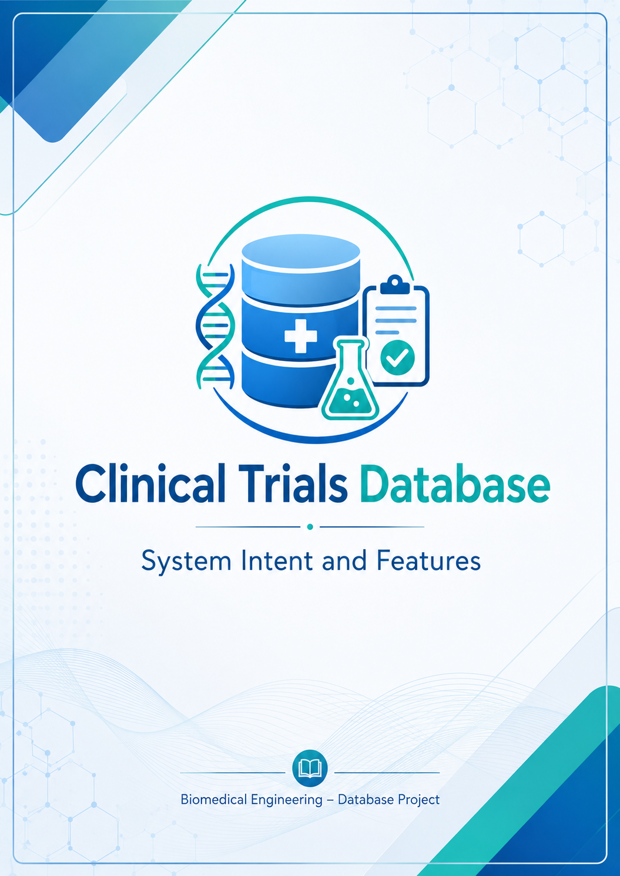

SYSTEM INTENT
The Clinical Trials Database is a Java-based system created to organize information related to clinical trials. The system stores data about trials, patients, doctors, hospitals, patient descriptions and users in one database.
The main purpose of the project is to make clinical trial information easier to find and manage. In a clinical trial, many different types of data are connected. For example, a patient belongs to a trial, a doctor can be assigned to a trial, and a trial can be carried out in one or more hospitals.
Because of this, we decided to create a structured database where all this information could be stored in a clearer way. The system allows users to consult existing trials, manage patients and doctors, and see how the different parts of the trial are related.
Another important part of the system is the use of roles. Not all users need the same options, so the application has different types of users: Trial Manager, Doctor, Patient and Guest. Each role can access only the options that are useful for them.
Overall, the intent of the system is to centralize clinical trial data and provide a simple way to manage and consult the information from one application.

MAIN SYSTEM FEATURES
The system includes several features that allow users to manage and consult clinical trial information in an organized way. These features are connected to the main entities of the database and to the different user roles.

Feature | Description
Trial management | The system allows clinical trials to be created, viewed, updated and removed when necessary.
Patient management | Patients can be added to clinical trials and connected with a hospital, trial and medical description.
Doctor management | Doctors can be stored in the database and assigned to specific clinical trials.
Hospital management | Hospitals involved in clinical trials can be registered and connected with trials.
Patient descriptions | The system stores medical information about patients, such as gender and medical cause.
Role-based access | Different users have different permissions depending on their role: Trial Manager, Doctor, Patient or Guest.
Searches and reports | The system can search patients by medical cause and generate useful information such as patient results, average duration and average budget.
XML support | Some data can be exported or imported using XML files.
Database connection | The system stores and manages information using a relational SQLite database.

These features help the system organize clinical trial data and make the main information easier to consult and manage.

USER ROLES

The system includes different user roles to control access and organize the available options. Each role has a specific purpose inside the Clinical Trials Database.

Role | Purpose
Trial Manager | Manages the clinical trial workflow, creates trials, assigns doctors, enrolls patients and consults reports.
Doctor | Works mainly with patient information and patient descriptions.
Patient | Consults personal trial information and result status.
Guest | Accesses general information with limited permissions.
Role-based access helps the system stay organized because each user can only access the options related to their responsibilities.

DATA MANAGED BY THE SYSTEM

The Clinical Trials Database stores different types of information related to the clinical trial process. Each type of data represents one important part of the system and helps connect the main entities.

Data Type | Purpose
Trials | Stores the main information of each clinical study, such as name, starting date, duration, budget and target patients.
Doctors | Stores information about doctors and the trials they are assigned to.
Hospitals | Stores the hospitals involved in clinical trials.
Patients | Stores patient information, results and their connection with trials and hospitals.
Descriptions | Stores medical information related to patients, such as gender and medical cause.
Users and Roles | Stores login information and controls access permissions.
This data structure allows the system to organize clinical trial information in a clear and connected way.

FINAL SUMMARY

The Clinical Trials Database provides a structured system for organizing and consulting clinical trial information. It connects trials, patients, doctors, hospitals, patient descriptions and users in one relational database.
The main features of the system support the basic management of clinical trials, including trial management, patient enrollment, doctor assignment, hospital management, patient descriptions, searches, reports, role-based access and XML support.
Overall, the system makes clinical trial information easier to manage and helps users access the data they need according to their role.

